**Case Study of College Database**

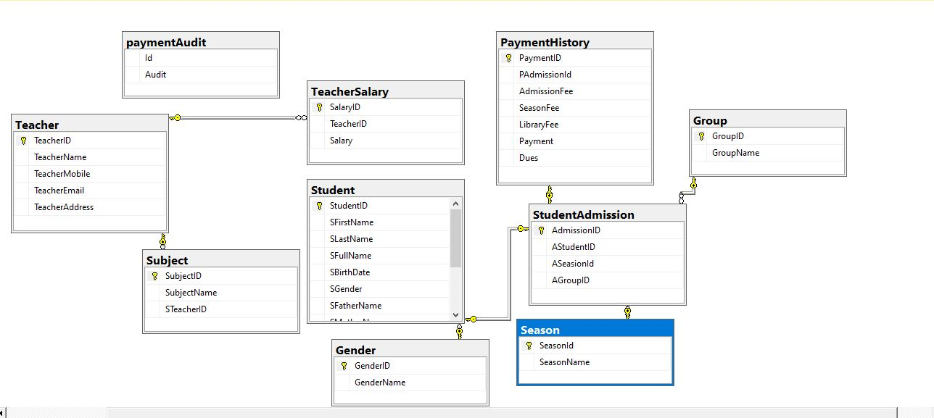I designed a database for Colleges. This has been built in Microsoft SQL Server database ensuring the high level security and automated backups. This is highly scale-able and SQL tuned system to ensure fast response and delivery quality outputs in timely manner. very simple and easy to use admin panel along with easy customization. It delivers a wonderful service for both student and the college administration so that student will not require to rush into the college to check their **Payment history** Don’t need to worry about storing your paper copy of **student records**. User friendly and reliable, error control, easy to use.